**Work Profile:**

* ROCK BOLT: Design, Supply and installations of 25mm dia.Rock bolt (SN bolt) along the slope. Fixing the bolt with resin &cement capsule &plate size of 150x150x10mm along with hexagon nut.The length of each bolt shall be as per design. The entire length of bolt shall consist of thread at top.
* Drilling &laying Weep hole /drainage hole pipe along with anchoring work (75mm dia)
* Installation and supply of Vegetation mat (Coir mat 450 GSM) above steep slope, fixing with 8mm U-pins &planting vetiver plant on the slope.
* Seeding and Mulching (Soil Cut Slope). Providing and laying Napier seeds/lemon grass & vetiver plants along the slope.
* **Cement pressure grouting** in anchors through hollow soil/rock anchor of outer dia of 38/32mm in rock /overburden including all cost of materials and equipment's required to complete the grouting work at desired pressure.

**Location:** Ravangla-Kewzing Stretch, (Sikkim) **Chainage No**. 47. **Client:** SPS Technocrats Pvt. Ltd.   
**Ref:** WO/SPS/RLRP/2023-24/78

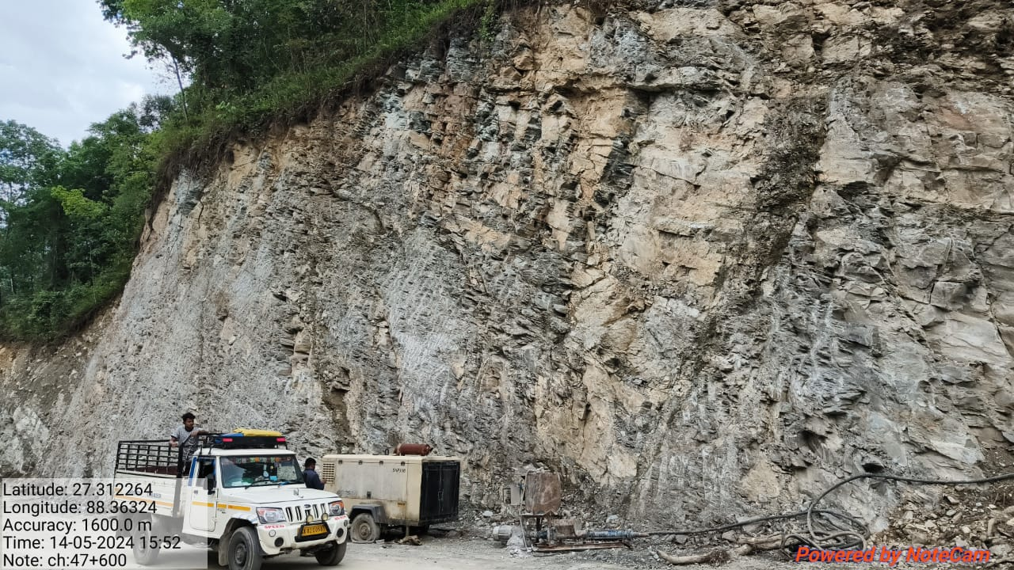

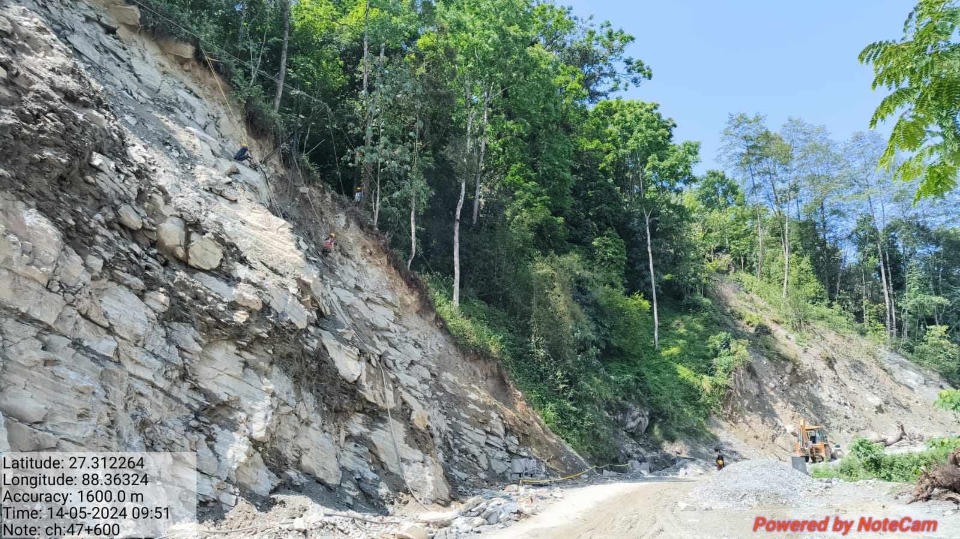

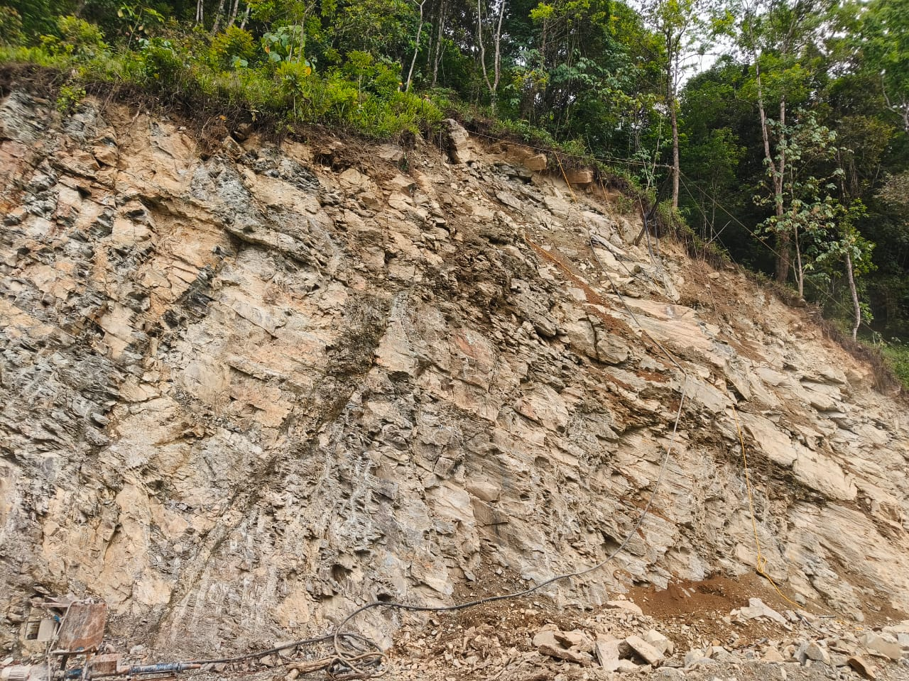

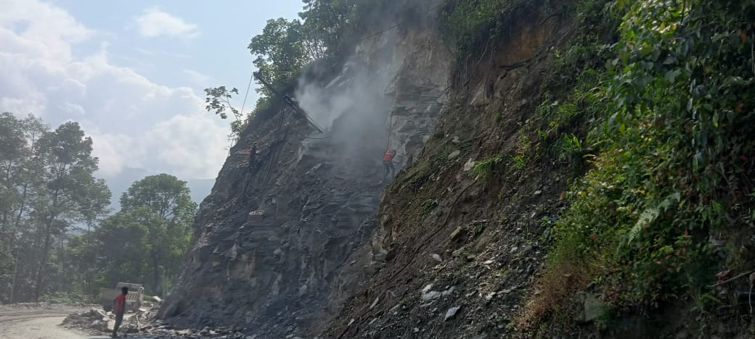

**Work Profile:**

* Supply and installation of SDA of 38 m / 32 m diameter as per Design, yield load >=400kN, drill hole of 76mm, hexagonal nut, washer plate, coupler for connecting bars, drill bit (in case of self-drilling anchors) and full length grouting with admixture including all ancillary items for foundation anchoring and as per technical specification etc. complete as per detailed technical specification. Bonded Non-Woven Geo textile (125 GSM) indigenously manufactured from high quality polypropylene staple fibers for separation, drainage and filtration application with necessary overlaps as per the specifications.
* Providing and laying of EC marked needle punched and mechanically bonded non-woven geotextile indigenously manufactured from high quality polypropylene staple fibres for separation, drainage and filtration application with necessary overlaps as per specifications.

**Location:** Guwahati,Assam. **Client:** Anil Das Constructions Pvt. Ltd.

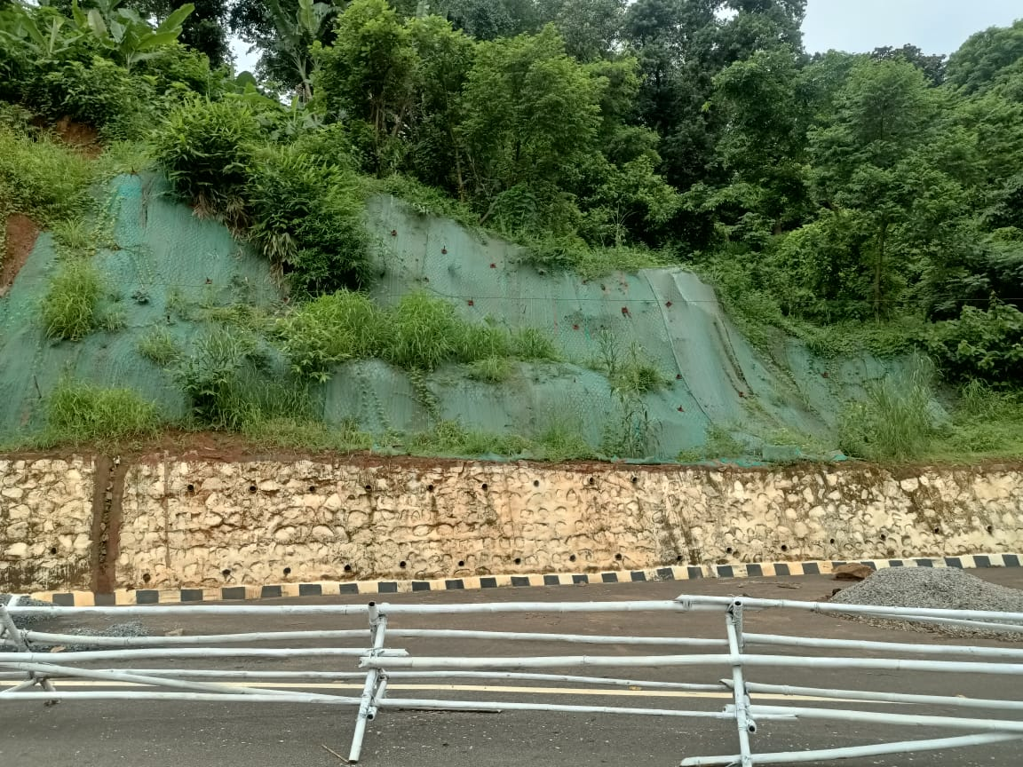

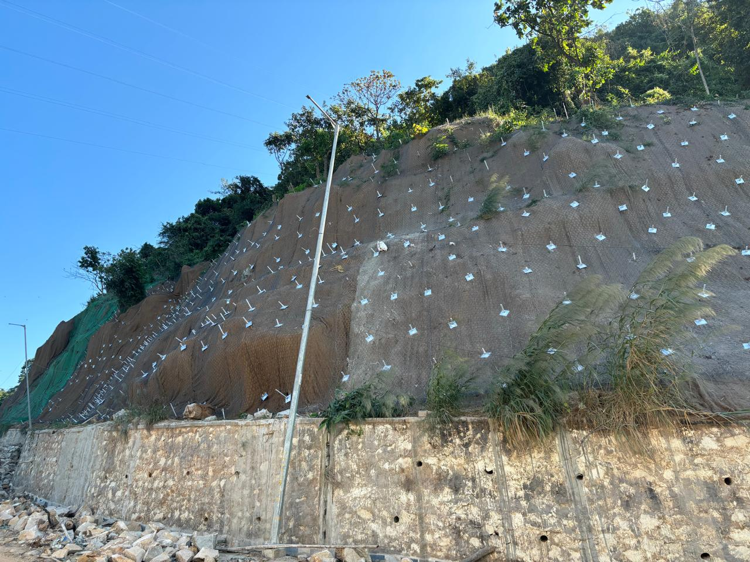

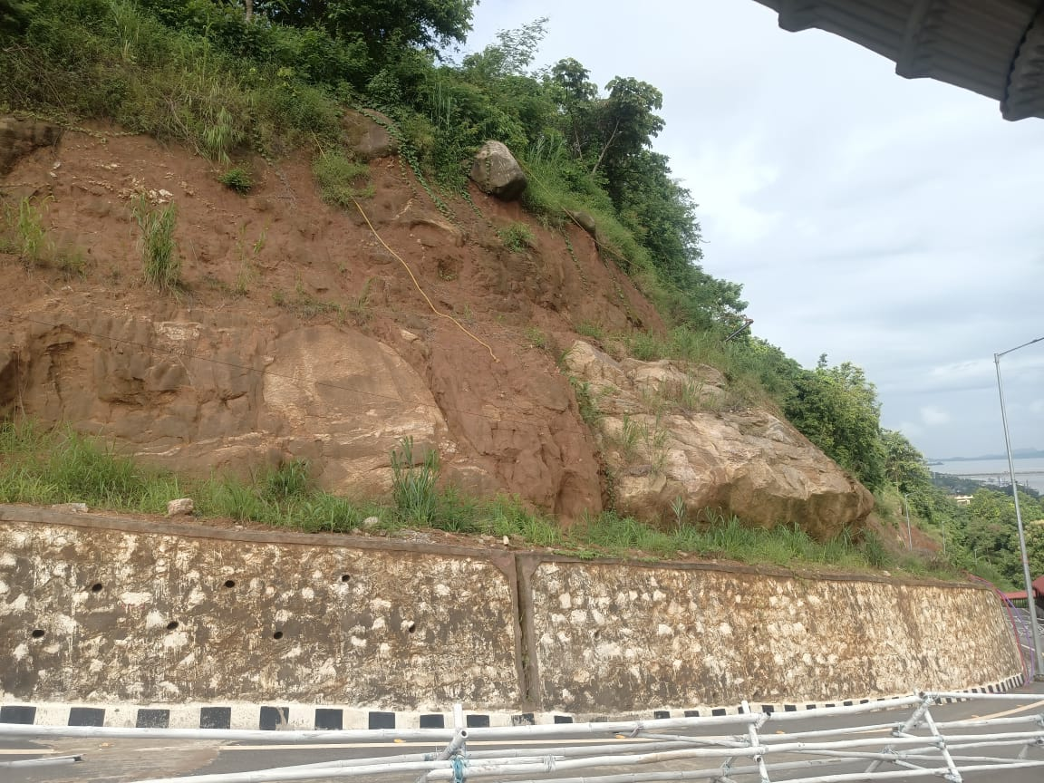

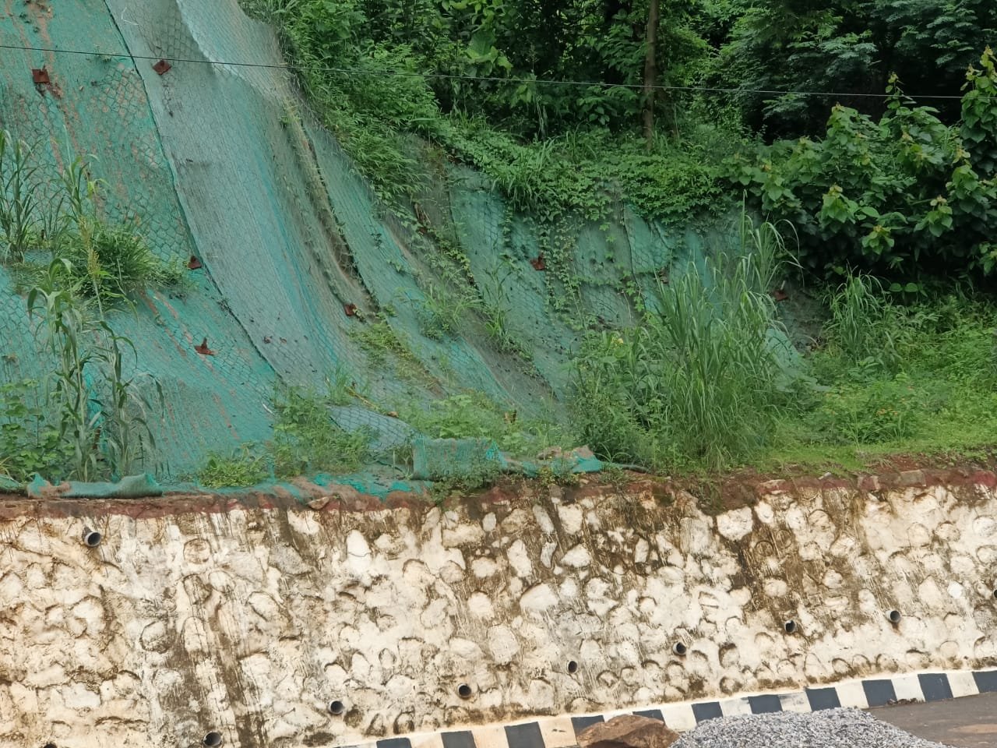

**Work Profile:**

* Supply,Installation and Grouting of 32mm dia SDA (Self-Drilling Anchor) as per Design, of drilling depth of 6m. With hexagonal nut, washer plate, coupler for connecting bars, drill bit and full length grouting with admixture including all ancillary items.

**Location:** Betkutchi, Guwahati, (Assam)**.  
Client:** NCC Limited. (Formerly Nagarjuna Construction Company Ltd.) **Ref:** NCC/IDC-BETKUCHI/WO/25.

